EXPT NO:4B | EXPLORATORY DATA ANALYSIS-DATA INSPECTION,  FILTERING, STATISTICAL ANALYSIS AND  CORRELATION

AIM:
To visualize the ocean plastic pollution using Python and create different charts to understand student academic performance and identify important patterns.
PROCEDURE:
- Start the program.
- Import Pandas, Matplotlib, and Seaborn libraries.
- Load the Ocean Pollution CSV dataset.
- Display the first few records using head().
- Create a bar chart to compare different oceans based on their average Water Pollution Index.
- Create a pie chart to show the distribution of pollution records across different oceans.
- Create a line chart to analyze the relationship between Year and Plastic Waste.
- Add suitable titles, axis labels, and legends.
- Display all the visualizations.
- Analyze the graphs and identify important patterns in the Ocean Pollution dataset.

CODE:

import pandas as pd
import matplotlib.pyplot as plt
import seaborn as sns
df = pd.read_csv("Ocean_Pollution_Dataset.csv")
print("First 5 Records:")
print(df.head())

ocean_pollution = df.groupby(
"Ocean"
)["Water_Pollution_Index"].mean()

plt.figure(figsize=(8, 5))

plt.bar(
ocean_pollution.index,
ocean_pollution.values
)

plt.title("Average Water Pollution Index by Ocean")
plt.xlabel("Ocean")
plt.ylabel("Average Water Pollution Index")
plt.xticks(rotation=25)

plt.show()
ocean_counts = df["Ocean"].value_counts()

plt.figure(figsize=(7, 7))

plt.pie(
ocean_counts.values,
labels=ocean_counts.index,
autopct="%1.1f%%",
startangle=90
)

plt.title("Distribution of Ocean Pollution Records")

plt.show()
yearly_plastic = df.groupby(
"Year"
)["Plastic_Waste_Tonnes"].mean()

plt.figure(figsize=(8, 5))

plt.plot(
yearly_plastic.index,
yearly_plastic.values,
marker="o",
label="Plastic Waste"
)

plt.title("Year-wise Average Plastic Waste")
plt.xlabel("Year")
plt.ylabel("Plastic Waste (Tonnes)")
plt.legend()
plt.grid(True)

plt.show()
print("\nVisualizations displayed successfully.")
print("\n--- ANALYSIS ---")

print(
"Ocean with highest average Water Pollution Index:",
ocean_pollution.idxmax()
)

print(
"Ocean with lowest average Water Pollution Index:",
ocean_pollution.idxmin()
)

print(
"Year with highest average Plastic Waste:",
yearly_plastic.idxmax()
)

print(
"Highest average Plastic Waste:",
yearly_plastic.max(),
"Tonnes"
)

print("\nImportant patterns can be observed from the bar, pie and line charts.")

print("\nExperiment 4B completed successfully.")

OUTPUT:

First 5 Records:
Year Ocean Country Plastic_Waste_Tonnes Oil_Spill_Tonnes \
0 2015 Pacific Philippines 33795 1260
1 2015 Atlantic South Africa 62131 3319
2 2015 Indian China 80955 2833
3 2015 Arctic China 77150 589
4 2015 Southern India 49551 1928

Marine_Debris_Tonnes Water_Pollution_Index Microplastic_Level_mg_L \
0 47158 58.49 1.51
1 25023 62.26 1.62
2 14311 69.54 1.89
3 28118 69.29 1.68
4 20394 59.82 1.63

Affected_Marine_Species Cleanup_Cost_USD
0 104 19050
1 104 28579
2 93 30317
3 109 25154
4 102 20845
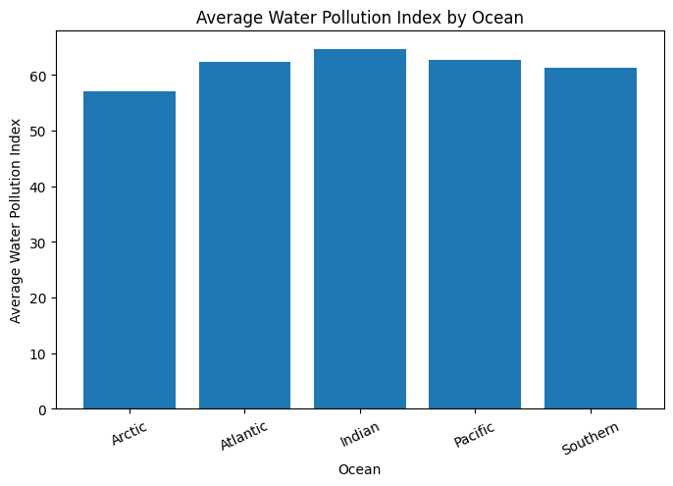
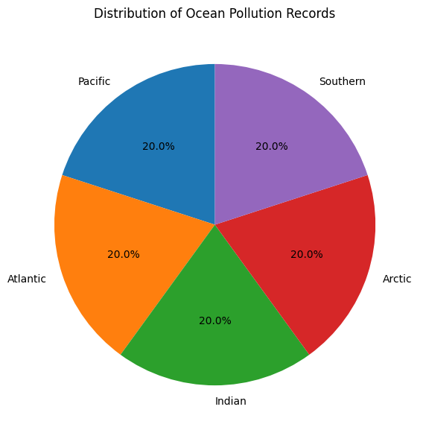
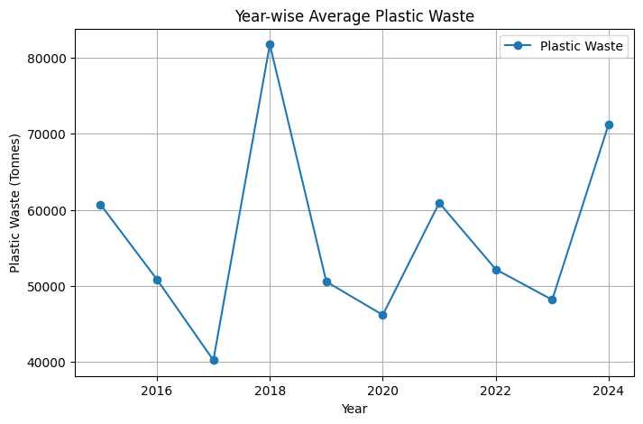

Visualizations displayed successfully.

--- ANALYSIS ---
Ocean with highest average Water Pollution Index: Indian
Ocean with lowest average Water Pollution Index: Arctic
Year with highest average Plastic Waste: 2018
Highest average Plastic Waste: 81743.6 Tonnes

Important patterns can be observed from the bar, pie and line charts.

Experiment 4B completed successfully.

Result:

